HOME EXERCISE PROGRAM INSTRUCTIONS

General Comments:

Congratulations! You have completed the supervised training portion of the study and now you are being given a home exercise program to help maintain any gains you have made with therapy and to further improve your functional ability. We would like you to continue performing the home exercise activities at least 2 times per week. We have provided you with several exercise log sheets so that you can record when and how much of the exercises you have performed each week.

There are two parts to these instructions. In the first part, we will review how and when to fill out the exercise log sheets. In the second part, we will provide you with detailed descriptions with pictures of the exercises.

Instructions for Completing the Home Exercise Log Sheet

The exercise log sheet should be filled out each time you do your home exercise program. We are having you do this so that we can keep track of how much home exercise is performed by each participant over the course of the study. You will not be penalized in anyway if you are not always able to do the home exercise program. We only want to know how much is actually being done compared to how much was prescribed by your therapist. You will be asked to return these log sheets to the study coordinator each time you come in for a follow-up examination. You will be payed $5.00 for returning the exercise log sheets at each follow-up visit.

Therapist’s Exercise Prescription: At the far left of the table, you will see the column titled “Therapist’s Exercise Prescription.” For each exercise, your therapist will indicate either the number of repetitions, or how much time to be spent on each exercise. If the therapist leaves this column blank for a given exercise, this means that you do not have to do this exercise.

Week (record start date of week): Across this row, each cell represents 1 week of time. We would like you to record the date of the Monday for the “start date” of that week. You will perform two home exercise sessions during each of these weeks.

Date of Exercise: You will notice that there are 2 columns of the date of exercise under each Week column. Please put the date of the day you performed the home exercise program under the corresponding week. If you only do one exercise session for a given week, only fill out one column.

Recording Exercises Performed: Under each “date of exercise” column is the list of possible exercises you will have performed. Simply write the number of repetitions or the amount of time you spent for each exercise in the corresponding cell for each exercise.

DETAILED INSTRUCTIONS OF THE HOME EXERCISES

Standing Calf Stretch: You will stand in front of a wall with your hands against the wall. You will place one leg back and one leg forward. You will slowly lean forward, keeping both heels of your feet on the floor until you feel a stretch discomfort in your calf. This will stretch the muscles in the back of your lower leg (calf muscles). You will hold the stretch position for 30 seconds and repeat the exercise 3 times. You will then repeat the exercise with the other leg being positioned in back so you can stretch the other legs calf muscles.

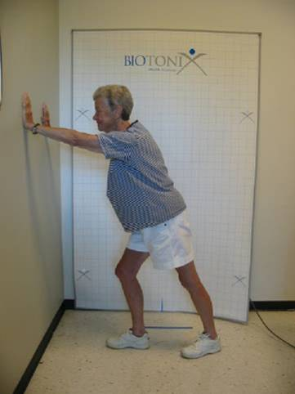

Hamstring Stretch: You will lie on your back. Bend the hip to the vertical position (thigh pointing up to the ceiling) and hold with your arms on the leg that is being stretched. Keep the other leg as flat to the ground as possible. Next, straighten your knee as far as you can on the leg that is bent up in the vertical position until you feel a stretch discomfort in the back of your thigh. This will stretch your hamstring muscles (the muscles on the back of your thigh). Hold the limb in the stretched position for 30 seconds. Repeat the exercise 3 times. Repeat the exercise on your opposite leg.

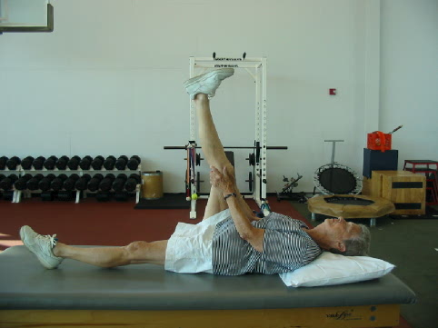

Quadriceps Stretch: You will kneel on one knee on the seat of a chair, facing the back of the chair, while standing on the other leg. Hold the back of the chair for balance. Keep your back straight and slowly lean forward toward the chair back until you feel a stretching sensation on the front of your thigh. Hold the limb in the stretched position for 30 seconds. Repeat the exercise 3 times. Repeat the exercise on your opposite leg. If you have difficulty doing the exercise with a chair, an alternative is to lie on your stomach, wrap a strap or towel around the ankle of the leg you will stretch, then pull the leg up toward your buttocks until you feel a stretch in front of your thigh. Hold the limb in the stretched position for 30 seconds. Repeat the exercise 3 times. Repeat the exercise on your opposite leg.

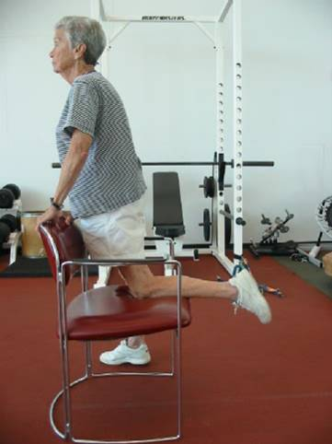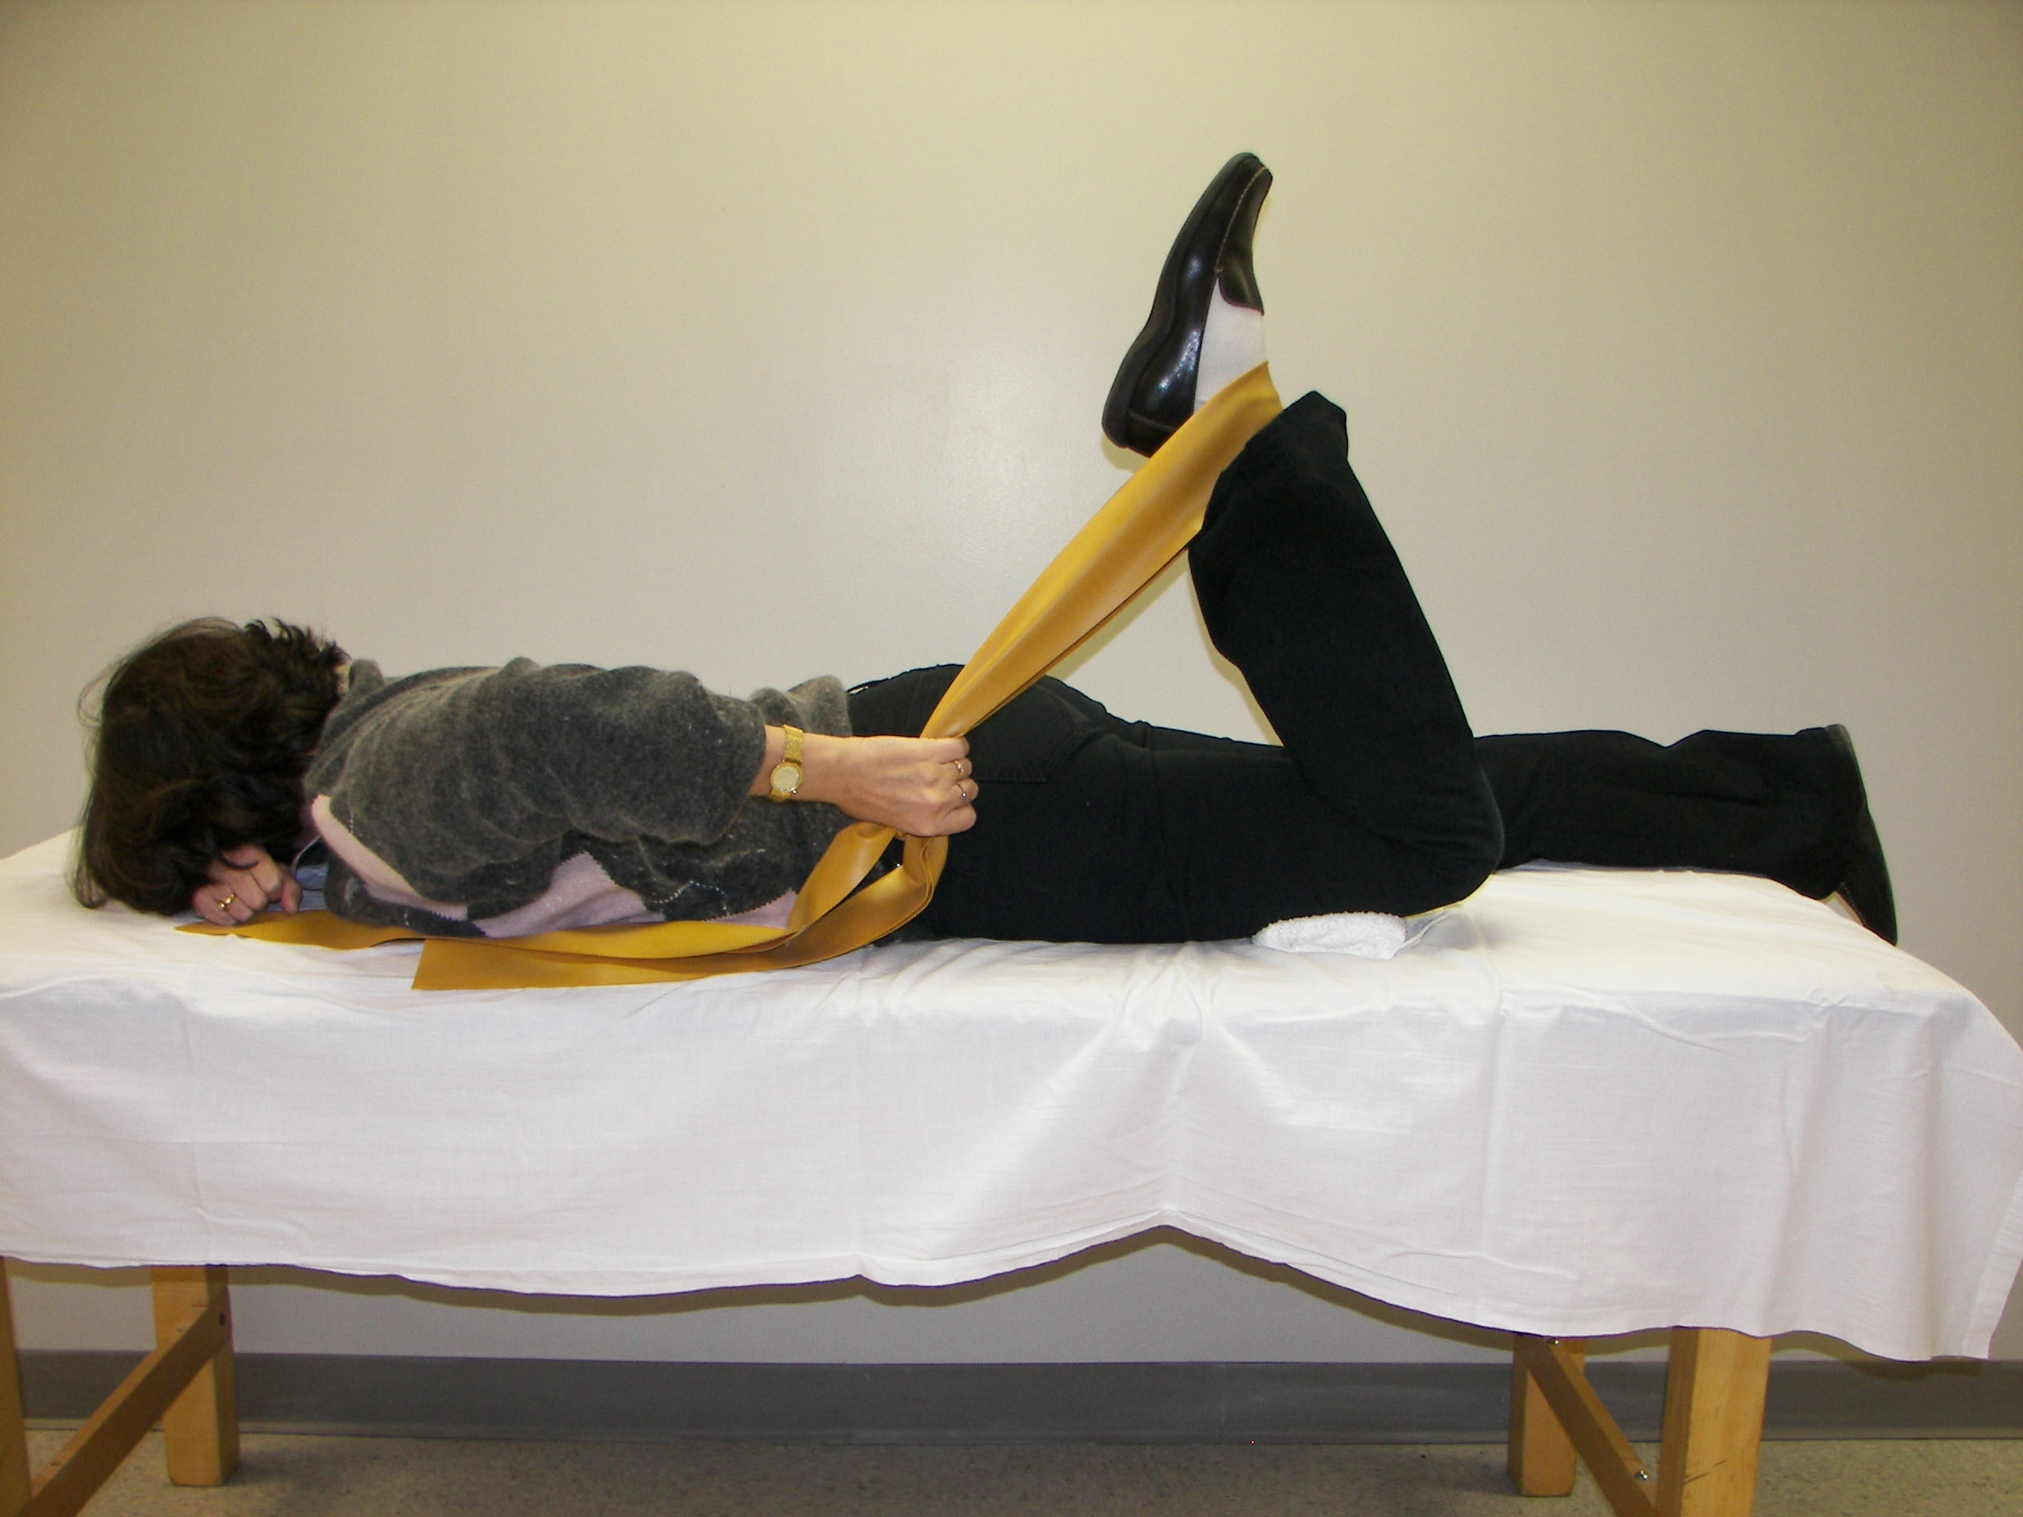

Straight leg raises (lying on back): You will place a cuff weight around the ankle of the leg you will exercise. Use the poundage prescribed by your therapist. You will lie on your back. You will bend the knee of the non-exercise limb up so that the foot is resting comfortably in a foot flat position. You will raise the exercise limb with the knee fully straight to the height of the other knee (about 15 to 20 inches), then lower the limb back to the table. Perform 3 sets of 10 repetitions on each limb. You should rest for 2 to 3 minutes between each set.

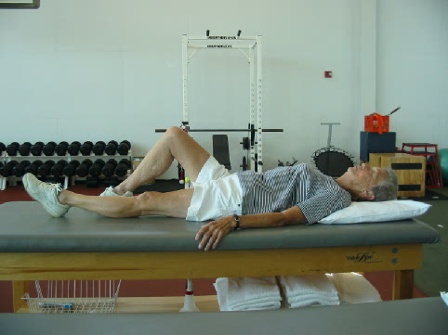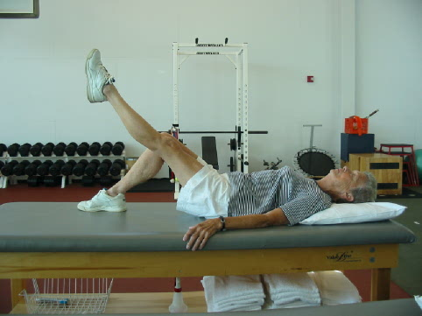

Start Leg Raise

Straight leg raises (lying on stomach): You will place a cuff weight that has been given to you by the research coordinator around the ankle of the leg you will exercise. You will lie on your stomach. You will raise the exercise leg upward as high as possible with the knee fully straightened, then lower the limb back to the table. Perform 3 sets of 10 repetitions on each limb. You should rest for 2 to 3 minutes between each set.

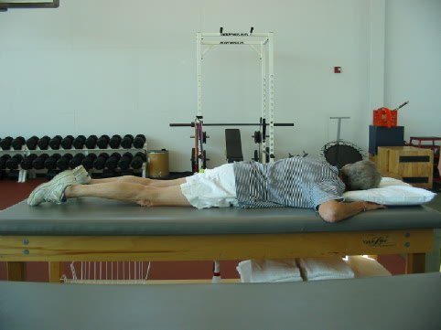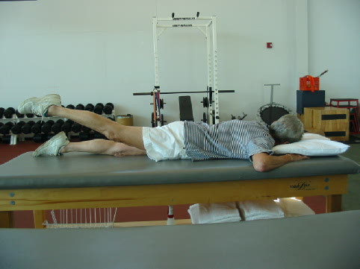

Start Leg Raise

Seated knee extension isometrics with Theraband: The research coordinator will provide you with a long piece of theraband. You will sit in a chair with one end of the theraband tied to the leg of the chair and the other end looped around your ankle. Tie the theraband tight enough so that you start with your knee at a 90 degree bend.You will straighten your knee about half way and hold for 3 -5 seconds, then return to the start position. Perform 3 sets of 10 repetitions on each leg. You should rest for 2-3 minutes between each set.

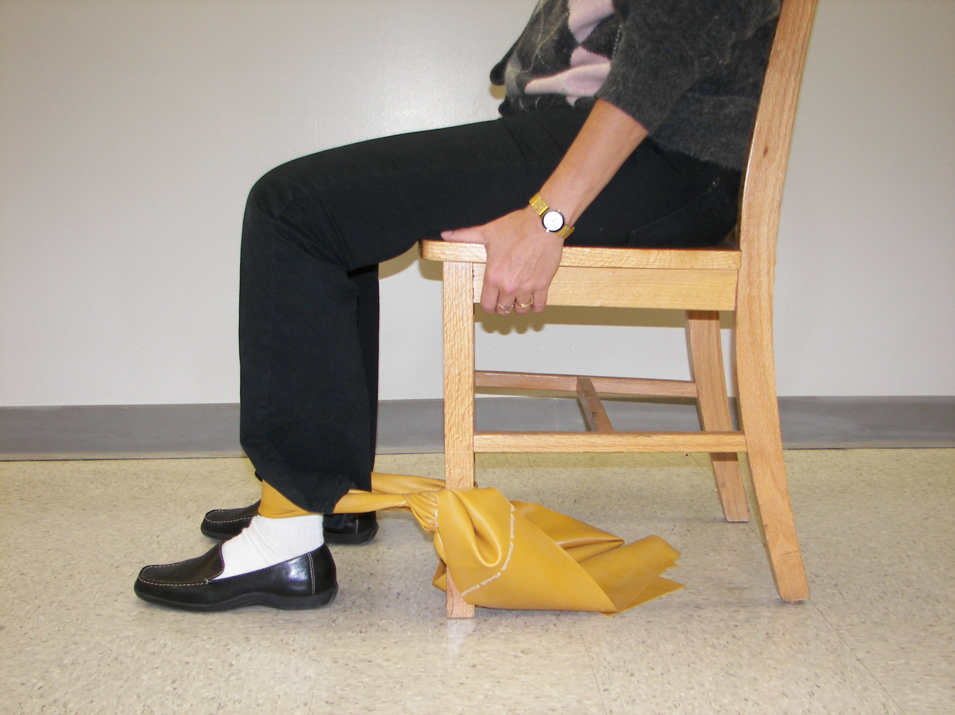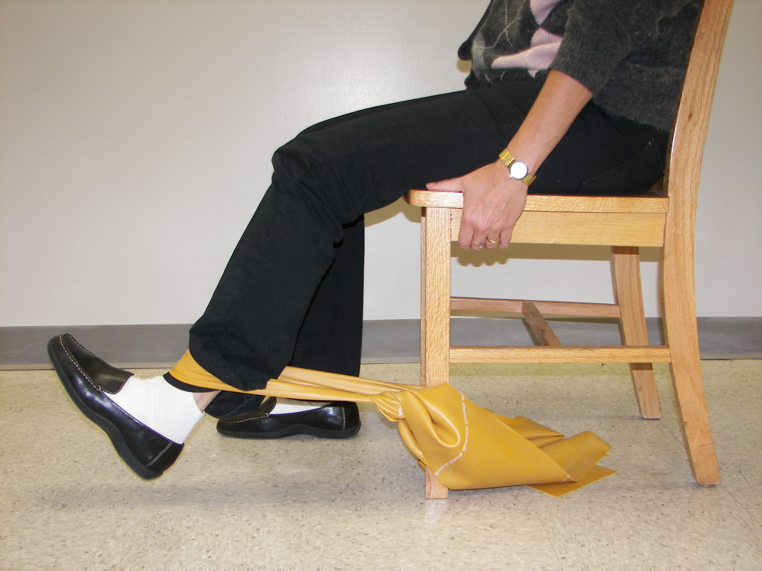

Start Position End Position

Wall Squats: You will stand with your back against the wall with your knees straight and your feet placed about your foot length’s distance from the wall. Slowly bend your knees to a ½ squat position, then return to the full straightened position. Perform 3 sets of 10 repetitions of this exercise. You should rest 2 to 3 minutes between each set.

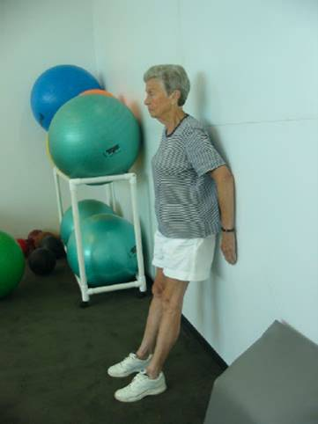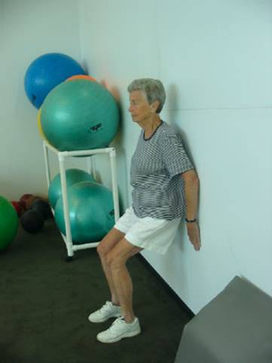

Start Squat Return

Standing Hamstring Curls with Cuff Weights: Wrap the cuff weight around your ankle. Stand facing a wall or door. Keeping your thigh on the exercise leg even with the thigh from the leg you will stand on, bend the knee on the exercise leg up so that the knee bends close to 90 degrees. Perform 3 sets of 10 repetitions. When you can perform all 3 sets at 10 repetitions, add another pound to the cuff weight.

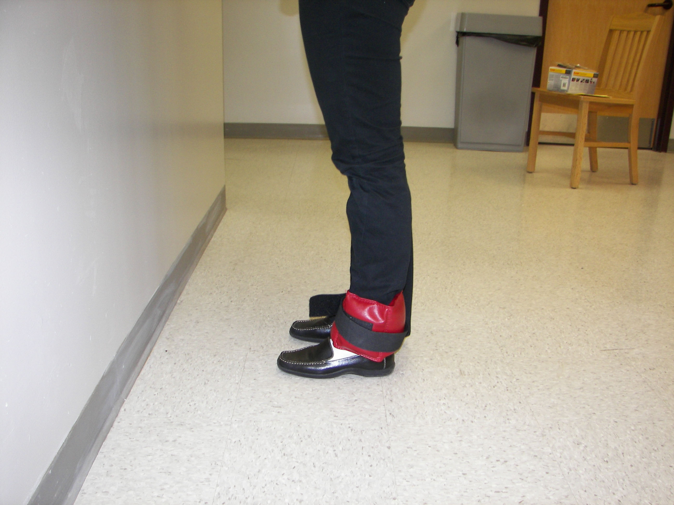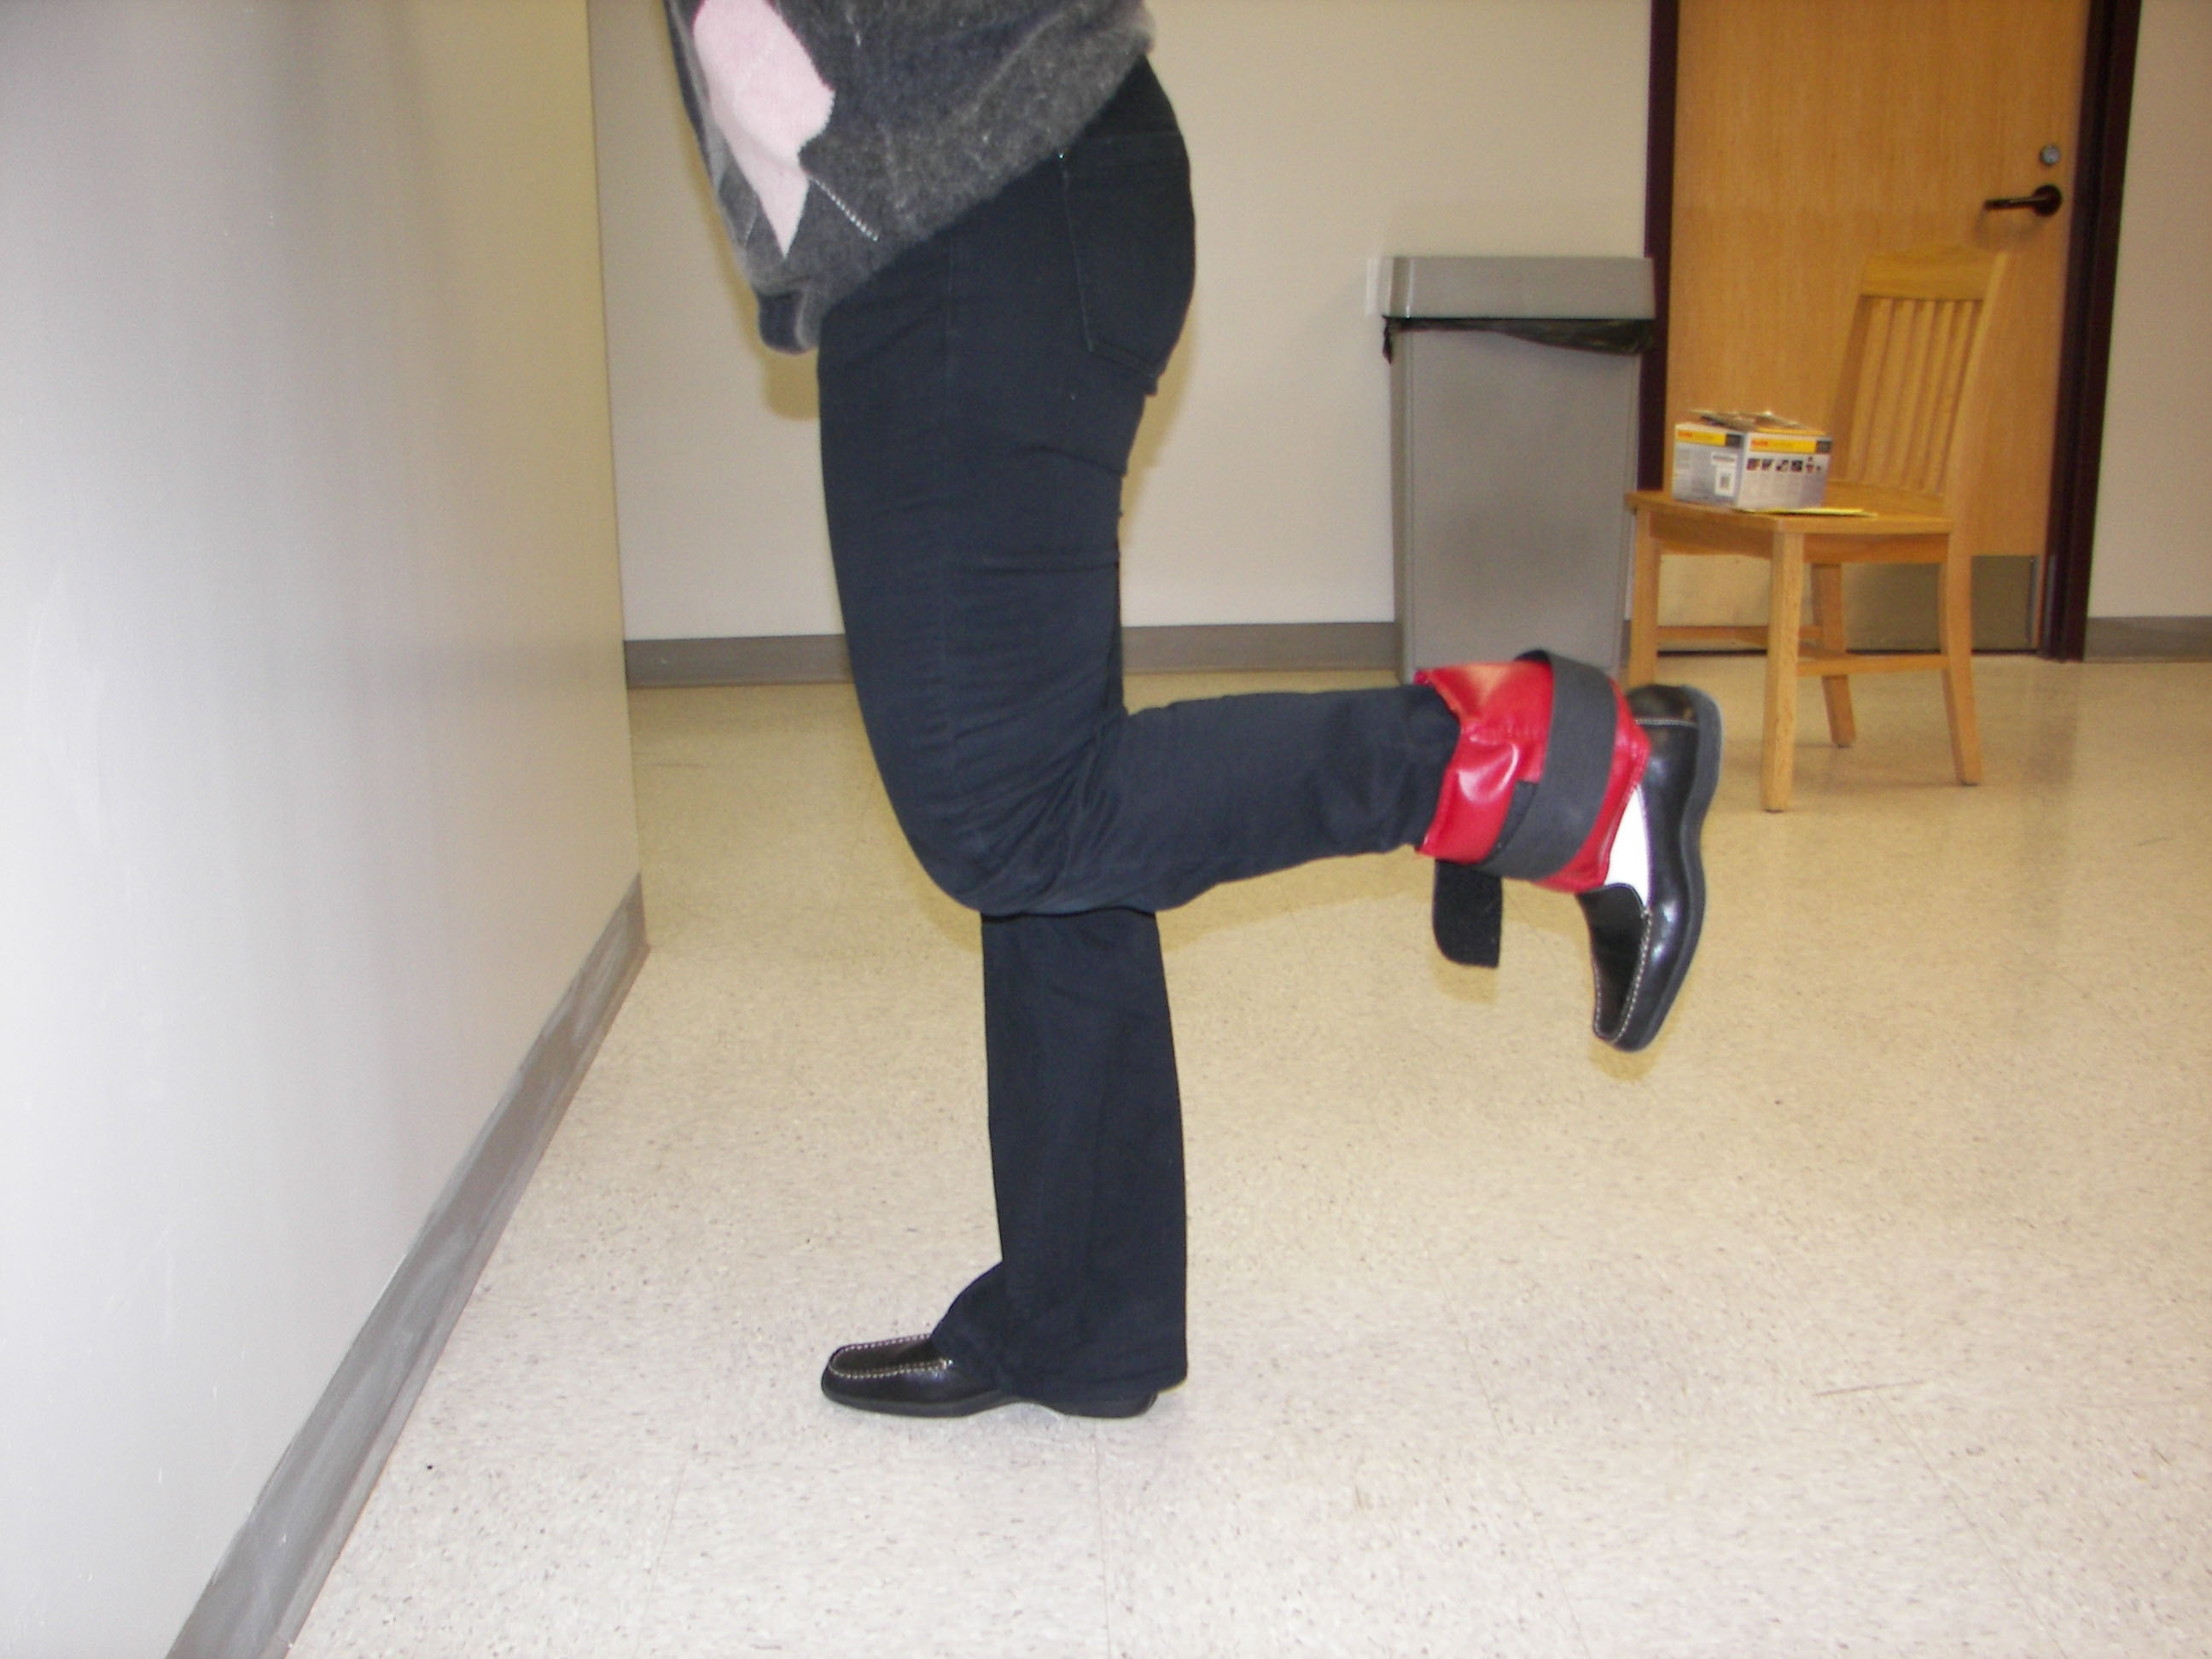

Start Finish

Standing Calf Raises: You will stand with both feet flat on the floor. You will rise up on the toes as high as possible, holding for 1-2 seconds then return to the foot flat position. Perform 3 sets of 10 repetitions of this exercise. You should rest 2 to 3 minutes between each set.

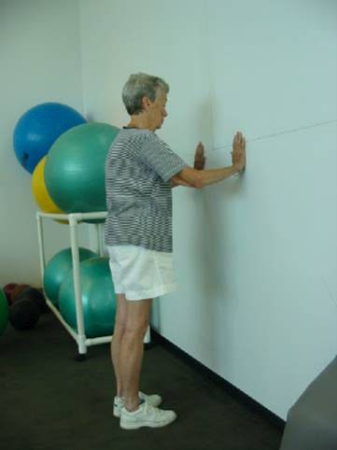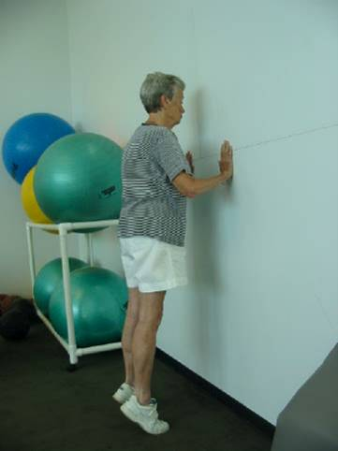

Start Finish

Walking: Your therapist will recommend a walking program for you. Please record how much time you spend walking each day that you perform your walking program.

Side stepping: You wil step sideways, moving right to left then left to right, approximately 10-20 ft, repeating 2 to 3 times in each direction.

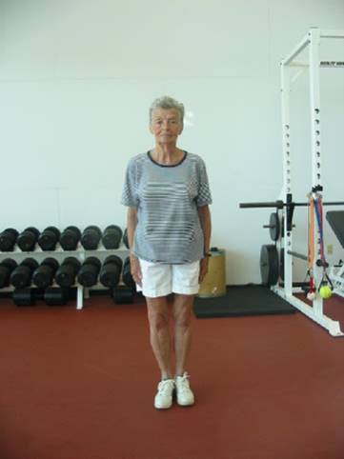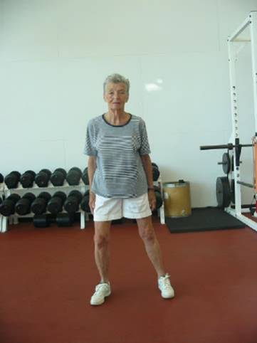

Start Step Stop

Braiding or Carioca Stepping: You will alternate front and back cross-over steps combined with side stepping moving right to left then left to right, approximately 10-20 ft, repeating 2 to 3 times in each direction.

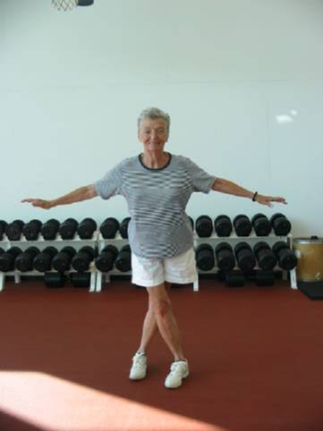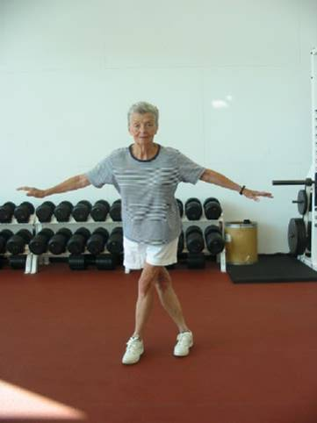

Step Front Cross Step Back Cross Step

Forward tandem walking: You will place one foot directly in front of the other, alternating legs with each step, as if you were walking a tight-rope, while walking as fast as you can without losing your balance for approximately 10 – 20 feet. Repeat 2 to 3 times.

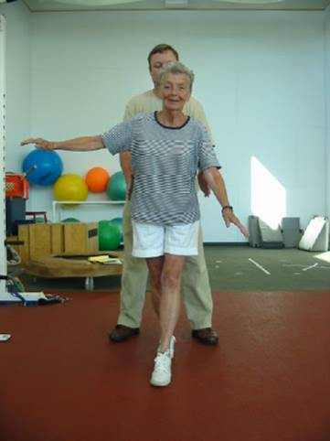

Forward Tandem Walking

Backward tandem walking: You will place one foot directly in back of the other, alternating legs with each step, as if you were walking backwards on a tight-rope, while walking as fast as you can without losing your balance for approximately 10 – 20 feet. Repeat 2 to 3 times.

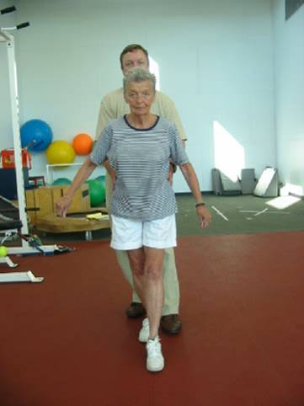

Backward Tandem Walking

Front cross-over steps during forward walking: You will cross one leg in front of the other, alternating legs with each step, approximately 10-20 feet, repeating 2 to 3 times.

Back cross-over steps during backward walking. You will cross one leg behind the other while walking backwards, approximately 10-20 feet, repeating 2 to 3 times.

Single Leg Balance: Stand on one leg, maintaining your balance for as long as possible, up to 30 seconds. You can try 2 to 3 times before switching to the other leg. Repeat on the opposite leg.



